Visual Bonus: Match the notable work of art with the film in which it was featured FFPE. More than one work may come from any given movie.
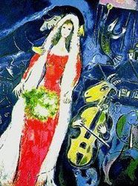
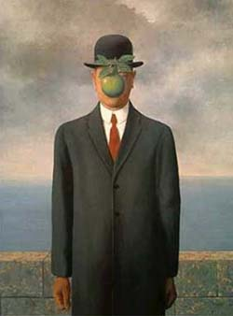
A. D.


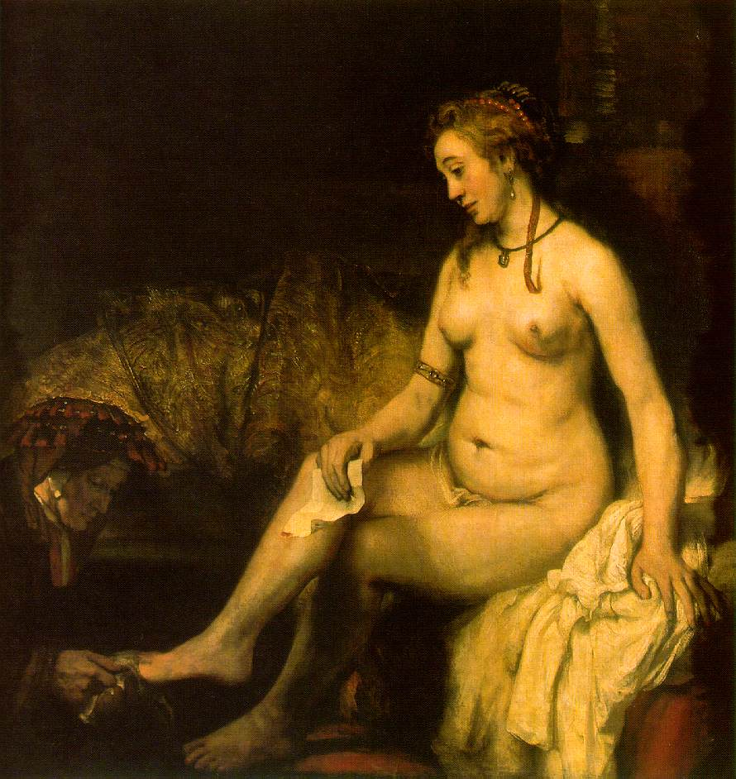
B. E.

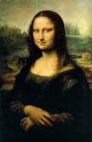
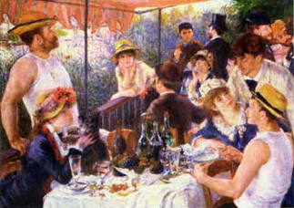
C. F.

1. Ever After
2. The Thomas Crown Affair
3. The Italian Job

4. Amelie
5. Entrapment
6. Notting Hill

Visual Bonus: Identify the stadiums from photos FTPE, if you need the name of the main tenant you’ll get 5.

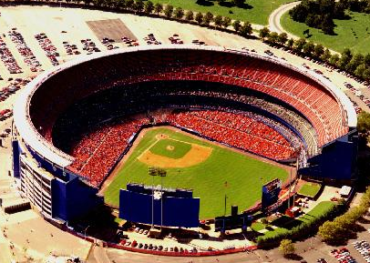
A.

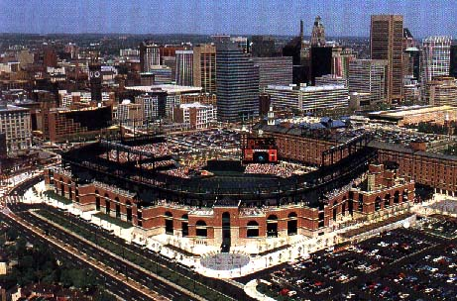
B.

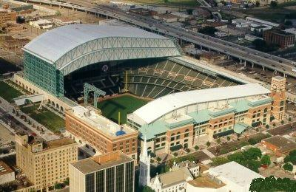
C.

Visual Bonus: Given a photo of a stadium or sports arena that will soon be built or that is being considered for construction, name the team that will play there FTPE.

A.

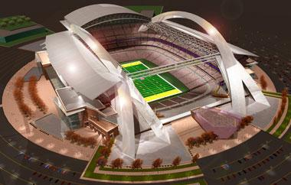
B.

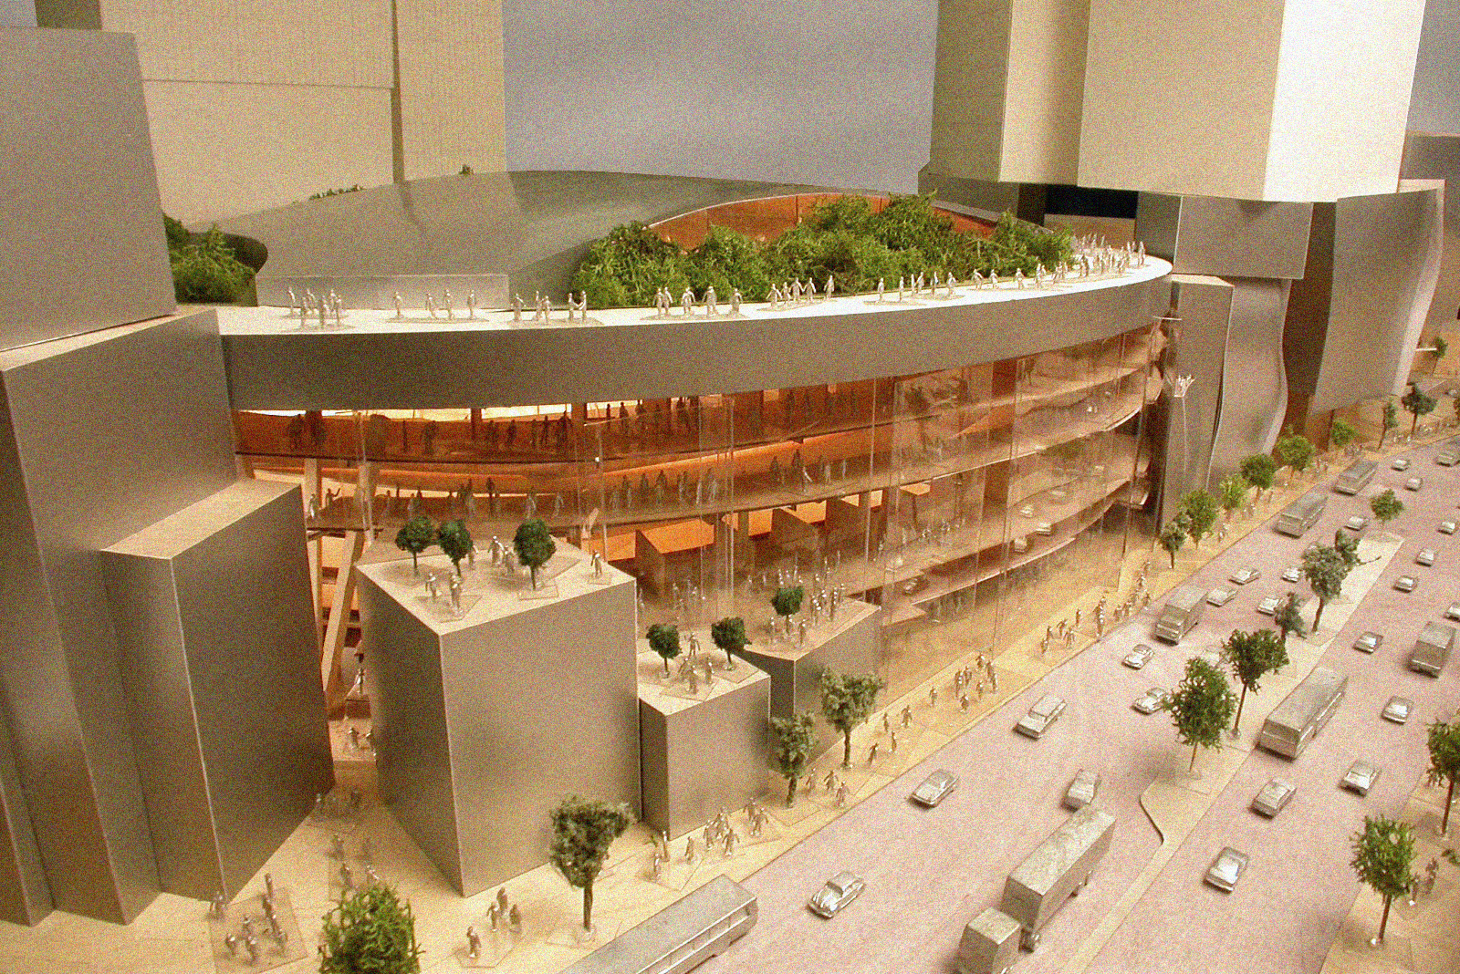
C.

Visual Bonus: Identify the stadiums of the past from photos FTPE, if you need the name of the team that played there, you’ll get 5.
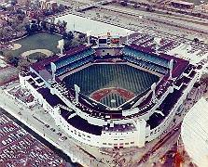
A.

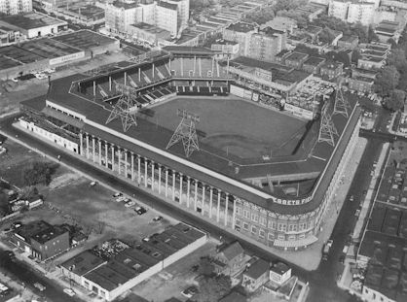
B.

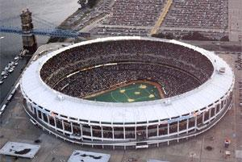
C.

Visual Bonus: Given an illustration of someone playing quidditch, name the position they are playing FTPE.

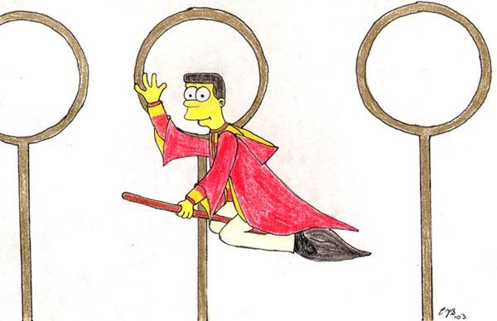
A.


B.

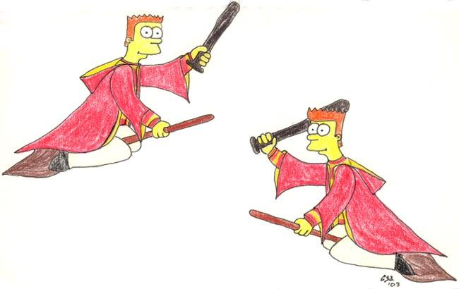
C.

Visual Bonus: Name the Bond movie from a movie poster that advertised it during its original release FFPE.

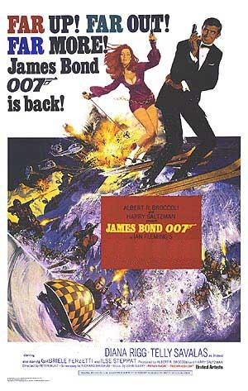
A.

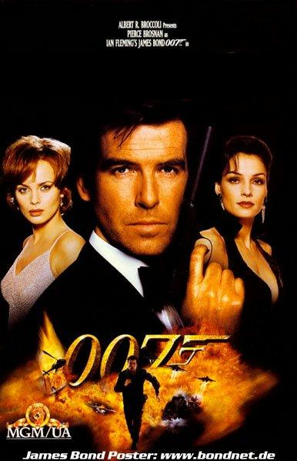
B.

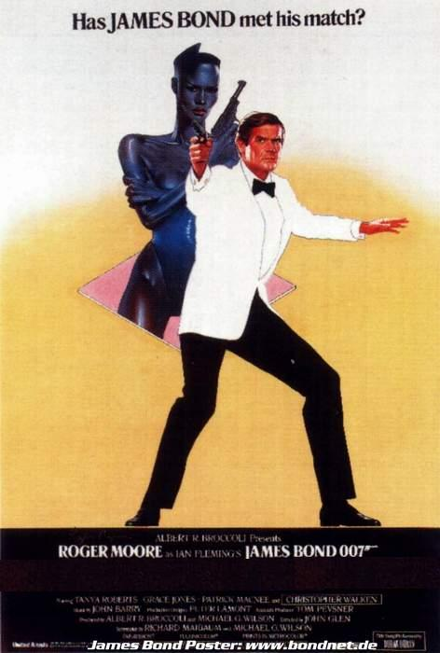
C.

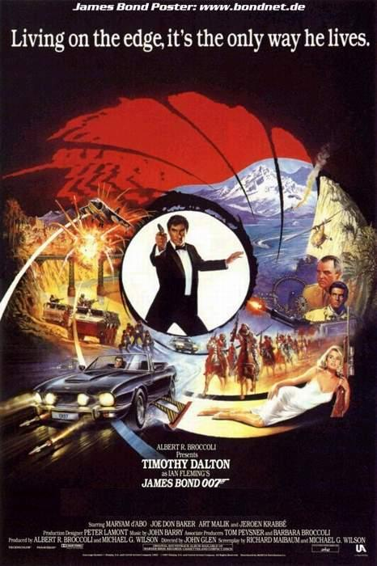
D.

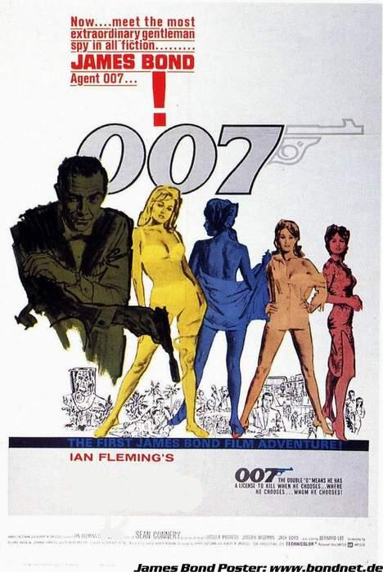
E.

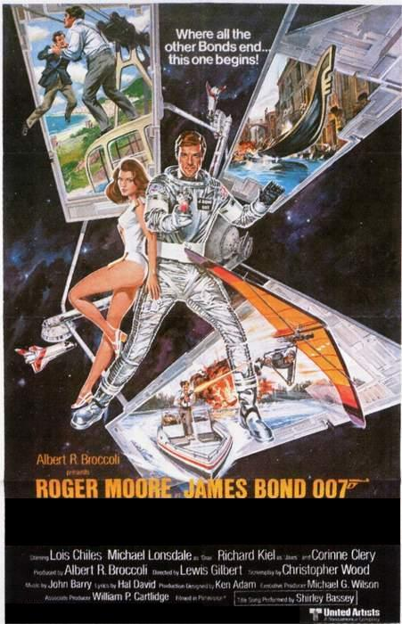
F.

Visual Bonus: Let’s face it, skin sells. Name these albums from album covers featuring humans in various stages of undress FFPE.

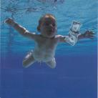
A.

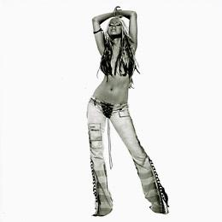
B.


C.

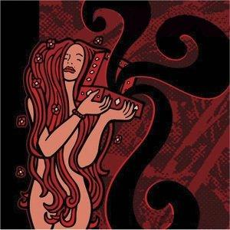
D.

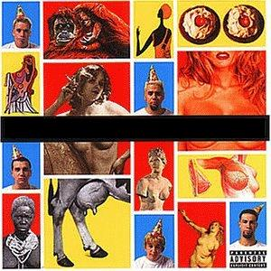
E.

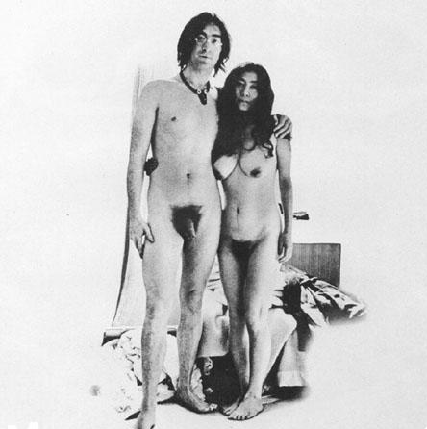
F.

Visual Bonus: Name these fine regional fast food establishments from their logo FFPE. There are two acceptable answers for part C.


A.


B.


C.

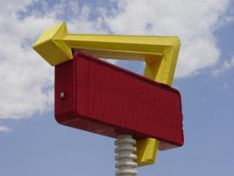
D.


E.


F.

Visual Bonus: Given a picture of a suggestion for a state quarter that appeared on “Late Night with Conan O’Brien,” name the state being parodied FFPE.

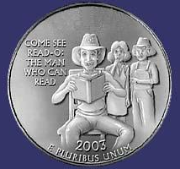
A.

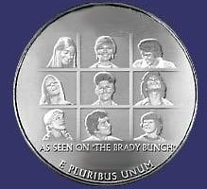
B.

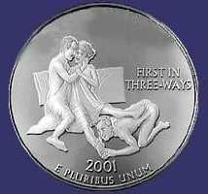
C.


D.

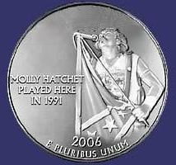
E.

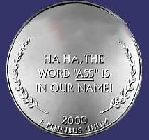
F.

Visual Bonus: Fark.com recently ran a Photoshop contest to create what classic video games would look like if they were produced now. Identify the Atari 2600 games parodied FTPE. Note, on part C we are not looking for Mortal Combat.

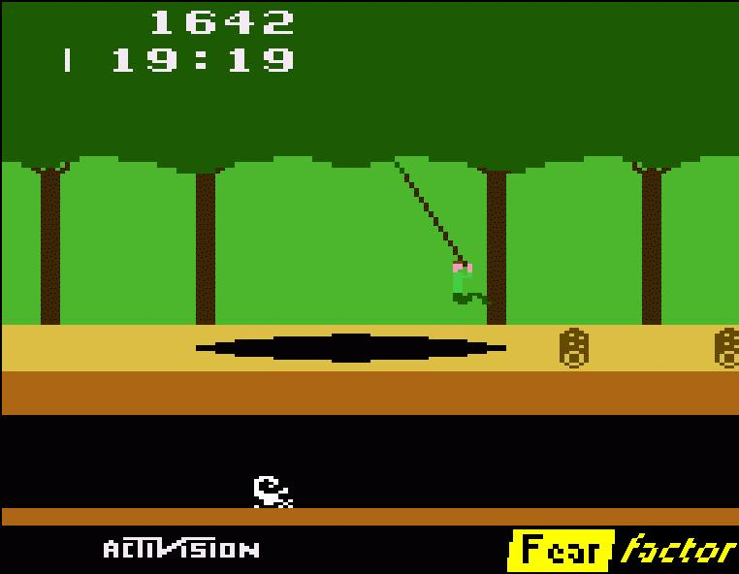
A.

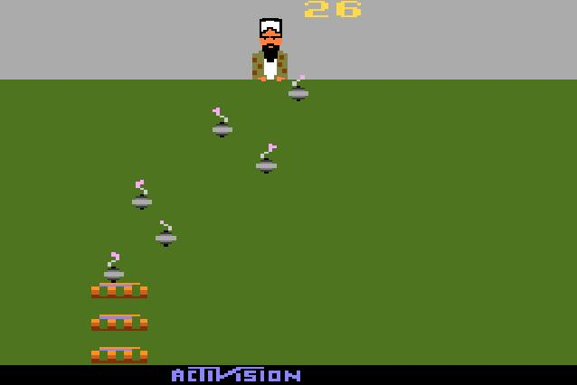
B.

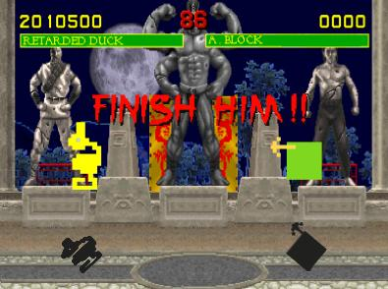
C.

Visual Bonus: Name these 80’s stars from their headshots FFPE. Did I mention, they were 80’s cartoon stars?

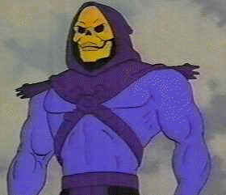
A.


B.

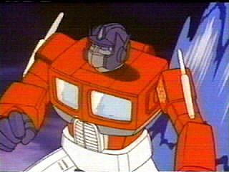
C.


D.

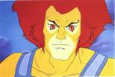
E.


F.

Visual Bonus: How well do you know your beer. Given a photo of a beer bottle cap with any identifying text removed, name the beer from which it came FFPE.

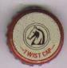
A.

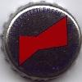
B.


C.


D.


E.


F.

